FOOD MANAGEMENT SYSTEM

**Use-Case Specification: Logout**

Version <1.0>

Revision History

|  |  |  |  |
| --- | --- | --- | --- |
| **Date** | **Version** | **Description** | **Author** |
| <7/12/2020> | <1.0> | <details> | <Nguyen Thu Trang> |

Table of Contents

1. Introduction 4

1.1 References 4

2. Positioning 4

2.1 Problem Statement 4

2.2 Product Position Statement 4

3. Stakeholder and User Descriptions 4

3.1 Stakeholder Summary 5

3.2 User Summary 5

3.3 User Environment 5

3.4 Summary of Key Stakeholder or User Needs 6

3.5 Alternatives and Competition 6

4. Product Overview 6

4.1 Product Perspective 6

4.2 Assumptions and Dependencies 6

5. Product Features 6

6. Other Product Requirements 7

6.1 Applicable Standards 7

6.2 System Requirements 7

**Use-Case Specification: Logout**

1. **Use-Case name**

**1.1 Brief Description**

This use-case defines the steps of logging out to the system as a admin. Admin can easily logout when he doesn’t want to access Restaurant’s system.

**1.2 Actor**

Customer

1. **Flow of Events**
   1. **Basic Flow**

Customer clicks the login button on restaurant’s home page. After that a login form appears, admin fills his username and password in that login form. Then clicks the login button. Eventually, the system redirects to the TAT Restaurant home page.

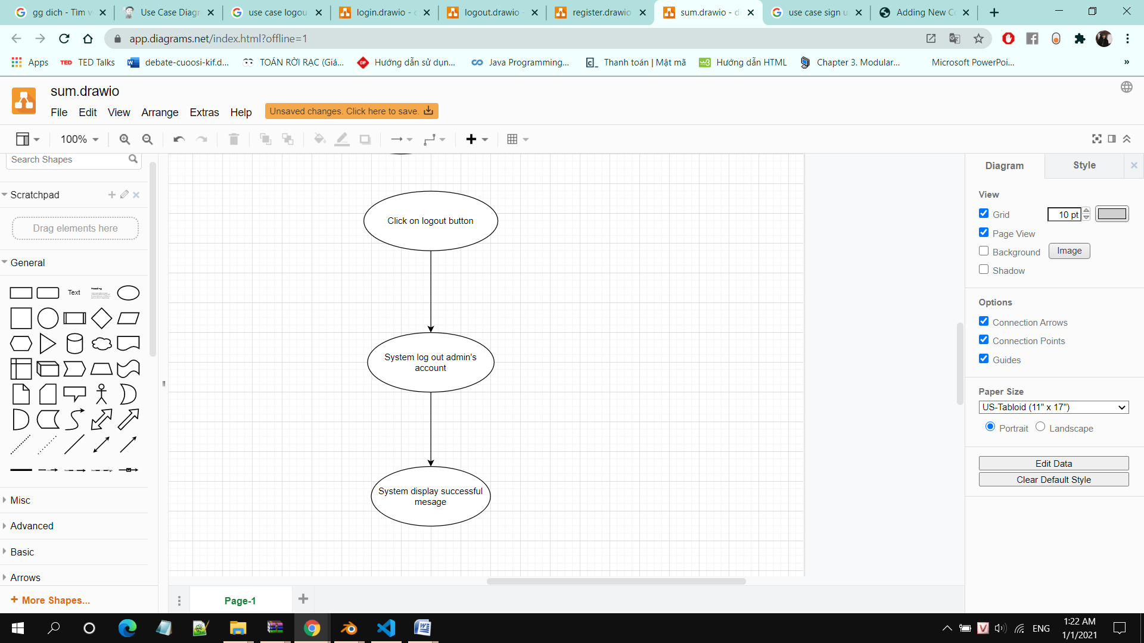

1. **Special Requirements**

None

1. **Preconditions**

Customer need to log in system.

1. **Postconditions**

System backs to log in page.

6. **Extension Points**

None